High Pressure Water Jets

Creation of Jet

Pumps
Pure water jets for cutting applications are used in a range between 10 to 400 MPa (1450 to 58013 psi) and created by pumps with intensifiers (high pressure and low volume flow). Pure water jets with high discharges are used for cleaning and milling applications. These jets are created by plunger pumps.

Nozzles
The water with a maximal pressure up to 400 MPa (58013 psi) is led by tubes made out of metal to nozzle. The high pressure causes a compression of the water, so that water can no longer consider as a fluid with a constant density. The compression of water forced with 400 MPa is up to 13 %. The water jet with a very high velocity (theoretically up to 900 m/s) is created by the change of potential energy (pressure) into kinetic energy in the nozzle.

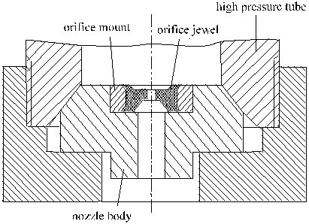
Fig. 1: Water jet nozzle assembly

The design of the nozzle is very easy. There is an orifice jewel, which is fixed by a orifice mount. Nozzles produces by different companies have different geometries of the Sapphire plate and a different design of the fixing. The life time of nozzles depends on the quality of water (erosion) and the amount of switch on and off with pneumatical or electrical valves (mechanical fatigue).

Velocity of the jet
The nozzle changes the potential energy of the water which is forced with a pressure into kinetic energy of the jet. The velocity of the jet can be calculated very simple with the equation of Bernoulli:
$v_{\text{th}}=\sqrt{\frac{2p}{ρ}}$
The change of energy shows losses. The used nozzles shows a sharp-edged flow channel which causes a contraction of the diameter of the water jet. The ratio of diameter of the jet and the diameter of the nozzle orifice is called contraction number α.

The contraction causes friction which reduces the average velocity in comparison to the theoretical possible velocity of the jet. The reduction of velocity can be taken into account by the velocity number which is defined by the ratio between velocity of the jet and the theoretical velocity of the jet. The velocity number can have values between 0.97 und 0.99.

The described effects reduces the theoretical possible velocity of the jet. The real velocity of the jet can be calculated by the following equation:
$\begin{aligned}v_{s}=\text{αj}v_{\text{th}} \\ {mv}_{\text{th}}\end{aligned}$
The number µ is the so called discharge coefficient µ and can have values between 0.65 and 0.7. This number can be practically evaluated by measurements of the volume flow, because it is very difficult to measure the contraction number and the velocity number.

Up to now the compressibility of water wasn’t considered in these contemplations. The higher density and higher inertia of the water cause a reduction of the velocity of the jet. On the other hand the expansion causes an increase of the velocity in the direction of the jet and an increase of the cross section of the jet. The real situation caused by all effects is very complex and depends on the design/shape of the nozzle.

Spreading of the jet
The water jet that leaves the nozzle spreads more and more with increasing the stand-off distance of the nozzle. This is caused by turbulences in the jet and by friction between the jet and the air and that results in a reduction of the velocity of the jet.

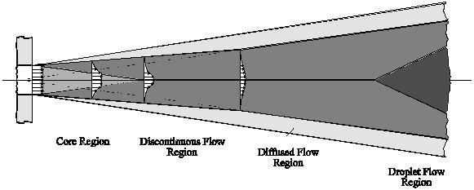
Fig. 2: Structure of a high pressure water jet

One possibility to influence the structure of the jet, that means to improve the length of the parallel and compact zone of the jet can be done by adding long chain polymers to the water. The polymers decrease the losses by friction in the nozzle and increase the average velocity of the jet. The improved coherence of the jet improves the quality of the edges of the cut if greater nozzle stand-off distances are used.

Mechanism of material removal
The removal of material by high pressure water jets is caused by a fluid dynamic erosion process. This process can be characterised by the following mechanisms:
- The friction between jet and work piece causes shear forces, which causes a plastic flow of the material out of the cutting die clearance.
- The high frequent-dynamic stresses of the material by the fluid particles of the jet cause a destruction of the material which can described by the following mechanisms: hardening of the material, cracking, crack growth, agglomeration of cracks and breaking out of material particles.
- The local dynamic pressure which interacts with the surface of the work piece gets into existing gaps like cracks and pores and causes an increase of these faults of the material in space to removal of the material.
- A local induced stress field by the local acting dynamic pressure causes cracks by passing a critical stress.

The described mechanisms exists alone or in combination depending on the properties of the material. The application for high pressure water jets in practise is only useful for the treatment of non-metal and non-ceramic materials.

Quality of the cut
The water jet a geometrical undefined tool and that is the reason why the quality of cut depends on the interaction between jet and work piece. Quality criteria of beam cutting technologies (laser, water jet, electron beam) like the geometry of the die clearance, the topography of the cut edge and the work piece properties. must be considered on their own.

The geometry of the die clearance can be characterised by the width of the die clearance, the rectangularity, the shape of the edge of cut and the burr.
The topography can be described by the roughness, the waveness and the striations at the lower part of the cutting surface.

The properties of the work piece can be described by a maybe existing heat influenced zone, induced and residual stresses, delamination, structure and micro cracks. It is not possible to make a general statement about the geometry of the cut curve if you know all properties of the material and the cutting parameters. Generally the cut curve looks like a V and shows a more or less round shape at the top of the curve.

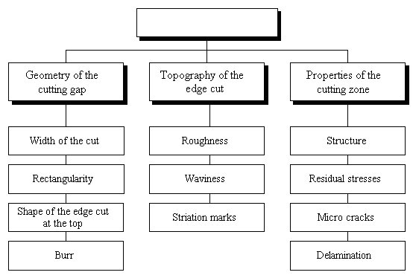
Quality criteria
Fig. 3: Quality criteria for beam cutting technologies

These effects are the results of the low intensity of the border of the water jet and the decreasing jet intensity with increasing cutting depth. Furthermore the cutting curve causes a self focusing of the jet which increases the intensity in the width of the cutting curve. In the worst case the cutting of very soft materials (like foamed plastics and foamed polystyrole) the width of the cut curve can increase from the top to the bottom. So the profile of the jet appears in the cutting curve. The influence of the most recent cutting parameters like pressure, cutting speed, stand-off distance and work piece hardness on the geometry of the cutting curve is shown in following figure.

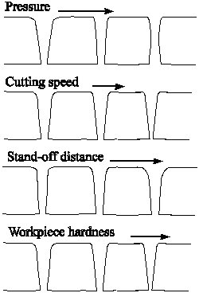

Fig. 4: Influence of the most important cutting parameters on the cutting curve
An increase of the pressure causes an increase of the average velocity of the jet and also an increase of the intensity of the boundaries of the jet. That’s the reason why the cutting curve becomes more and more parallel with an increasing pressure. On the other side there is an increase of the minimal width of the cutting curve.

These results are vice versa by increasing the cutting speed. The cutting curve looks like a V and becomes more narrow at the bottom. An increase of the stand-off distance results on one side in an increase of the cross section of the jet caused by the jet divergence and on the other side in a decrease of the average velocity of the jet caused by friction losses. Both effects results in an increase of the roundness of the shape of the edge cut at the top and the V-shape of the cutting curve.

The properties of the material influence the shape of the cutting curve, too. With an increase work piece hardness the shape of the cutting curve looks more and more like a V and the shape of the top becomes more rectangular.

The cut edge, which can produces with a cutting speed, limited by other parameters (cut through) can be divides into three sections. The first section on the top is macroscopically smooth and can be characterised by a roughness depending on cutting parameters and work piece properties. The third section at the bottom of the surface shows a macroscopically rough surface with tracks and striations. The section in the middle of the cutting surface can be described by a steady transition from the first to the third section.

By using the right parameters (high pressure, low cutting speed) the first section of the cutting surface can be expanded up to the whole thickness of the material and the whole cut edge shows a very high quality. The giving of cutting parameters makes only sense if there is some information about the quality which can reached with these parameters. Generally you have to reduce the cutting speed for a separating cut to 50 % to obtain a high quality cut under the same circumstances (same parameters and thickness of the material).

Following figure shows the relation between the parameters. The parameters are divided into input parameters, process parameters, result parameters and work piece properties. The pressure influences the velocity of the jet. The cross section of the jet depends on the stand-off distance and the nozzle diameter. The velocity and the cross section of the jet influence the distribution of the intensity of the jet. The intensity and the time of operation, which depends on the cutting speed, results in a local acting energy on the surface of the work piece which can used for the cutting process. The local available energy and the properties of the work piece influence the quality of the cut which can be characterised by the width of the cut curve, the shape of the cut curve and the quality of the edge cut. The maximum cutting depth the so called depth of kerf is influenced by these parameters.

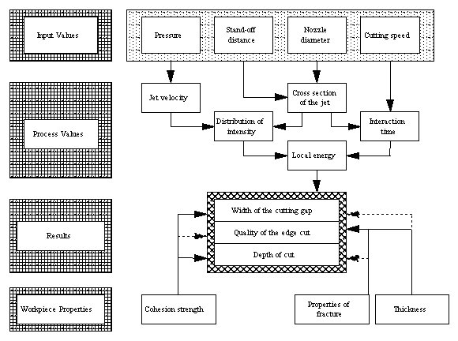
Fig. 5: Connection between the parameters of water jet cutting

Abrasive Water Jets

Creation of Jet

Pumps
By using abrasive water jets there are no limits for applications depending on the materials. The pure water jet mixed with abrasive particles can cut nearly every material. The abrasive water jet created by injection of the abrasive particles are used for cutting and separation operations in production engineering. The used pumps produce low discharges and high pressures. Normally pumps with intensifiers are used and plunger pumps are used for only a few applications.

Nozzles and cutting heads
The pure water jet cannot cut hard materials like metal and ceramics. That’s the reason why adding abrasive particles to the pure water jet. An additional mixing head (cutting head) is necessary to feed the abrasive to the water jet and to mix both to a jet. The abrasive water jet (AWJ) can created by using the injection principle.

The feeding of the high pressure water is done by a special high pressure tube. This high pressure tube carries the cutting head. The water jet nozzle creates the pure water jet. The diameters of these pure water jet nozzles used for the abrasive water jet applications are between 0,15 - 0,4 mm. The quality of water influences the lifetime (up to 200 hours) of the nozzles. The abrasive particles are fed by pneumatic hose into the cutting head. The abrasive particles are carried by air which is sucked in by the water jet. The particles are accelerated up to 500 m/s by the water jet in the focus tube. The length and the diameter of the focus tube depends on the diameter of the water jet nozzle. The diameter of the focus tube can be between 0,8 - 1,5 mm. The length of the focus tube must be between 40 to 100 mm to obtain an optimal acceleration of the abrasive particles.

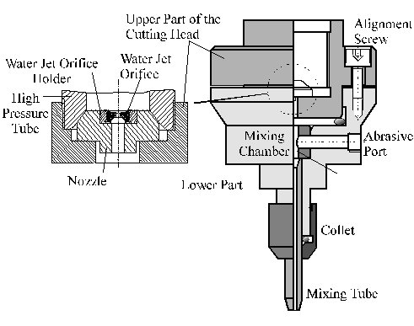
Fig. 6: Cutting Head (Injection principle)
The cutting head consists of an upper and a lower part. By using the alignment screws it is possible to align the centre line of the focus with the centre line of the water jet nozzle. This is very important, because the water jet must be able to pass the focus tube without any obstacles. If the water jet contacts the focus tube the wear of the focus tube will increase. The focus tube consists of special hard metal or borcarbid. It was possible to improve the wear resistance of focus tube materials during the last years. This was very important to improve the quality and the reliability of the cuts. The lifetime of commercial focus tubes is between 50 and 100 hours.

The pure water jet causes a low pressure in the cutting head by passing the mixing chamber and the focus tube. The low pressure sucks in a mixture of air and abrasive particles. Water, air and abrasive particles are mixed during passing the focus tube and leave the cutting head as a abrasive water jet.

Abrasive feeding system
All abrasive materials known form the sand blasting technology can be used for abrasive particles in abrasive water jets.

The required properties of the abrasive material depends on the application. For cutting operations generally sharp-shaped and mineral materials with high hardness are used. Typical abrasive materials are quartz sand, granat und korund with increasing hardness.

The size of the abrasive particles is between 0,1 and 0,7 mm. The maximal diameter of an abrasive practically should not be bigger than the half of the diameter of the focus tube. This important to provide blocks of the focus tube and to obtain an optimal acceleration process.
The abrasive particles are carried by air through a feeding tube and transported to the mixing chamber of the cutting head.

Cutting results
The top of the kerf, the parallelism of the edges, the topography of the edge cut and the burr are decisive for cutting results.

Effects of turbulences are the reason that some abrasive particles leave the abrasive water jet after the focus tube. These particles have less energy but cause a slight curving of the cutting edge. The radius is influenced by the stand-off distance of the cutting head. By increasing the stand-off distance the radius increases as well. This effect can observed only by cutting in air, not by cutting under water.

The cut kerf has a smooth surface up to the half of the depth of the kerf and a high parallelism of the edges. The width decreases in this region of the kerf between 0,1 - 9,2 mm. In the lower part of the kerf there is an increasing roughness and the surface shows a lot of striation marks. The kerf is no longer a line. This effect becomes more and more visible by a bad alignment of the nozzles.

The cutting speed has a great influence on the quality of the edge of cut. There are similar rules for the quality of the edge of cut as for the application of pure water jets. The edge of cut shows very deep striations for separation cuts (maximum cutting speed). The lower part of the edge of cut shows a high roughness and a high waviness. Generally a quality cut can obtained by half of the maximum cutting speed. The cut edge shows less striations and only a slight waviness that increases to the bottom of the kerf. This effect can observed by all materials in a similar way.

The distinction between separation cut and quality cut is decisive on the roughness on the cut edge. Furthermore it is important to distinguish between the roughness at the top and at the bottom of the edge cut.
Up to now there were no thermal stresses observed. There were no internal stresses found that may be caused by small deformations (hardening) of the micro cutting process. This is the great difference between abrasive water jet cutting and all the other thermal and mechanical cutting technologies. This advantage enables to cut materials and work pieces that need a finishing process (annealing treatment or burr removing) if they were cut by other cutting technologies.

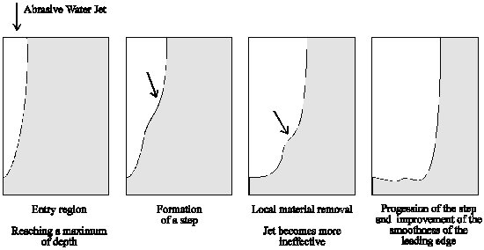

Fig. 7: Cutting process cycles

Advantages and disadvantages of the process

Advantages
- There is a so called non-thermal removal of the material which makes it impossible that the process causes a structural transformation or an oxidation on the cut edge.
- The use of high pressure water jets avoids the creation of chemical or toxic products.
- It is possible to cut filigreed and complex designs because cutting and friction forces are very low. There are only low holding forces required and the requirements to the guiding system are reduced. .
- The narrow cutting curves enables an optimal use of material utilization by using CNC-controlled flexible production systems.
- High pressure water jets can generally used for cutting several materials with different physical and chemical properties. The work piece properties influence the results in their quantity. High pressure water jets are especially useful for cutting sandwich and composite materials.
- High pressure water jets can cut in all directions and are especially useful for cutting designs with small radius with a minimum between 0,05 - 0,1 mm.
- During the cutting process the removed material is carried out of the cutting curve by the water jet. Therefore the cutting process produces no dust and no fumes, which is very important for cutting unhealthy materials.
- The plunge-cut can be initiated at nay point on the material.
- It is possible to cut with other fluids like oil or liquid chocolate.

Disadvantages
- The noise pollution is high. The cutting systems should be closed and the operator should wear a ear protection.
- The cut edge becomes wet.
- During the cutting process of composite materials the material can be delaminated and at the bottom of the cutting curve can appear several damages. These effects appear during the plunge-cut and by cutting with high traverse speeds. Generally it’s possible to cut these materials without damages and with high quality.
- Depending on the application the creation of vapour and smoke is possible.

